Leetcode question
Power of Two - LeetCode
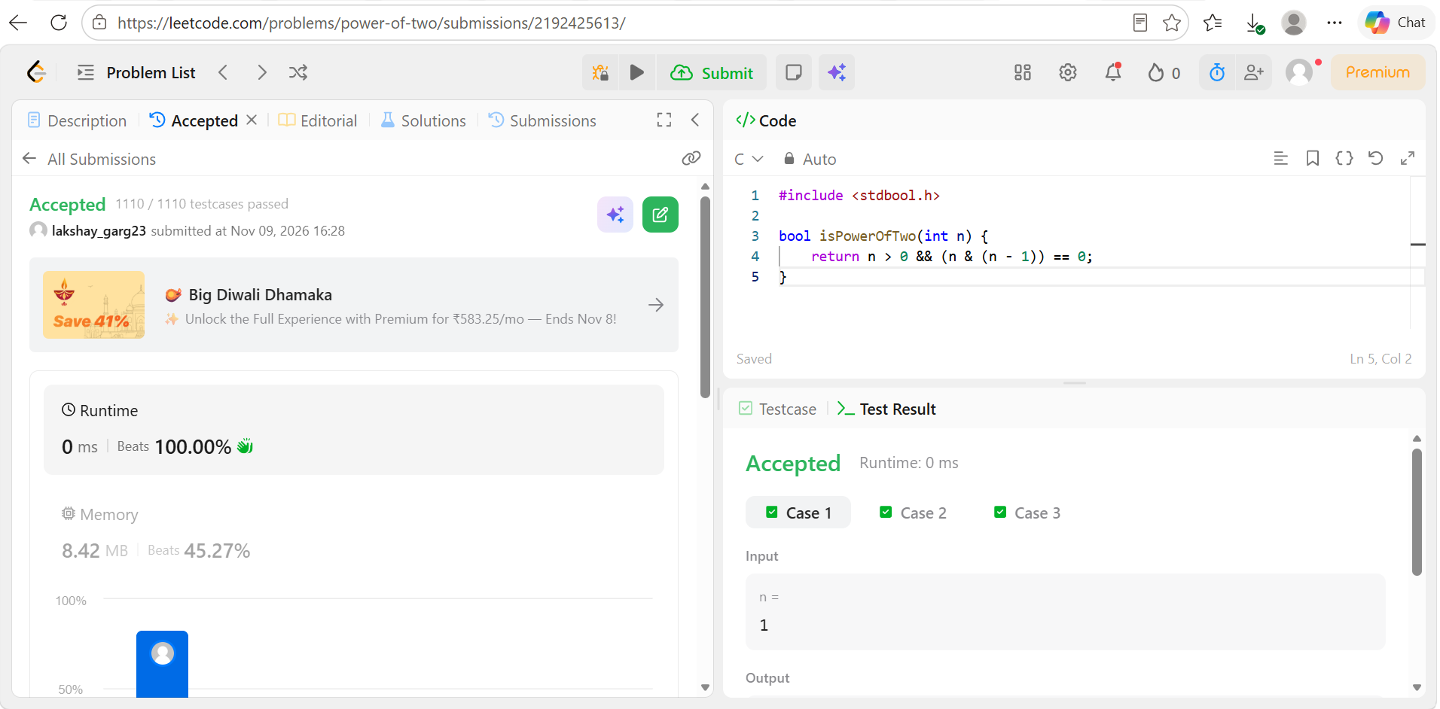
Code
#include <stdbool.h>

bool isPowerOfTwo(int n) {
return n > 0 && (n & (n - 1)) == 0;
}

